**Contents**



**Helpdesk Analyst**

1. Company Profile 3

2. Our Brand 5

3. Role Profile 6

4. Candidate Profile 6

# Company Profile

*Experian is a leading global information services company that unlocks the power of data to create opportunities for consumers, businesses and societies across the world.*

*During life’s big moments – from buying a home or car, to sending a child to college, to growing a business exponentially by connecting it with new customers – we empower consumers and our clients to manage their data with confidence so they can maximize every opportunity.*

*We gather, analyse and process data in ways others can’t. We help individuals take financial control and access financial services, businesses make smarter decisions and thrive, lenders lend more responsibly, and organizations prevent identity fraud and crime.*

*For more than 125 years, we’ve helped consumers and clients prosper, and economies and communities flourish – and we’re not done.*

*Our 17,000 people in 40 countries believe the possibilities for you, and our world, are growing. We’re investing in new technologies, talented people and innovation so we can help create a better tomorrow.*

**What we do**

We aim to place clients and consumers at the heart of everything we do. We help them to make the most of their data and realise their ambitions by enabling quicker, smarter decisions using our analytics and software.

The breadth, depth and accuracy of data, combined with analytics, help to drive informed and trusted decisions for our clients. We hold and manage powerful data sets, including credit data on 989 million people and 111 million businesses.

The data we hold varies, for example from how you have repaid credit in the past, to whether a car has been in an accident, to your eligibility for healthcare services in the USA, to how you like to respond to online advertising. Our industry experts collaborate with our data analysts and scientists to create innovative analytics and software to help solve our clients’ challenges.

We help millions of consumers to:

* better access financial services;
* understand and improve their financial position;
* protect their identity; and
* know that their data is correct.

We help thousands of businesses and organisations to:

* manage credit risk;
* prevent fraud;
* better understand their customers; and
* better understand their markets and allocate resources.

Our clients come from a wide variety of areas, including financial services (33%), consumers (19%), healthcare (7%), retail (5%), telecoms and utilities (5%), automotive (5%), insurance (4%), media/technology (3%) and government and public sector (2%).

We provide services in North America, Latin America, UK and Ireland and EMEA/Asia Pacific, and we manage and report our performance across those regions. North America accounts for the largest proportion of revenues (56%), while Latin America accounts for 17%, UK and Ireland for 19%, and EMEA/Asia Pacific for 8%.

We employ more than 17,000 people across 40 countries. Our corporate headquarters are located in Dublin, Ireland, with operational headquarters in Nottingham, UK; California, USA; and São Paulo, Brazil. We are listed on the London Stock Exchange and are a constituent of the FTSE 100 index. Market capitalisation was approximately £16bn as at May 2017 and, for the past five years, Experian has been named by *Forbes* magazine as one of the 'World's Most Innovative Companies'.

**Our business activities**

Our business activities in our regions are grouped into the following four areas:

**Credit Services (55% of revenues):** We help organisations lend responsibly and protect themselves and their customers from risk. From our 17 consumer and 11 business information bureaux, we provide millions of credit reports every day, enabling lending decisions to be made fairly, responsibly and quickly for people and businesses**.**

**Decision Analytics (13% of revenues):** We help our customers to lend effectively and to minimise the risk of fraud by developing advanced software and models to analyse data.

**Marketing Services (10% of revenues):** We help businesses to understand their customers. We use our strengths in data management and analytics to give our clients a clear picture of who each individual is and of their needs, so they can target relevant offers and communications to each individual.

**Consumer Services (22% of revenues):** We empower people to take control of their credit – helping them to understand and better manage their financial position, while protecting themselves from identity theft and fraud.

**Our strategy**

Our strategy is focused on delivering a significant growth agenda supported by several foundational principles:

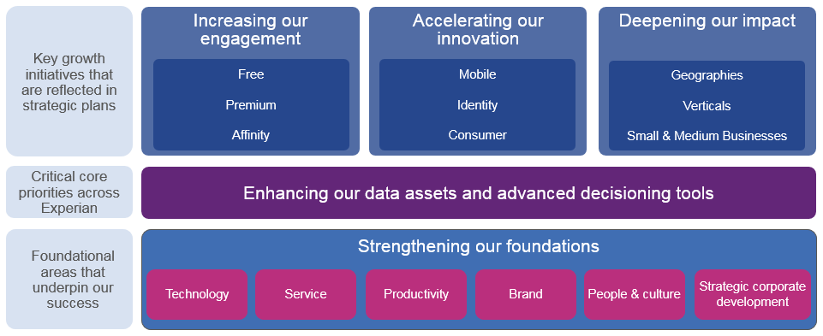

# Our Brand

Our brand brings to life our strategy of putting clients and consumers at the heart of everything, being more collaborative through a ‘One Experian’ approach and even more innovative. It embodies a clear ambition for us to help people and businesses create a better future for themselves.

Our core beliefs are:

1. Data is central to how we all live. It has the potential to transform all our lives for the better.
2. We can unlock the power of data to realise opportunities for people and organisations.
3. It is how we can help that sets us apart. We place the power of data and our expertise in the hands of our customers, creating opportunities and helping them plan for a better future with confidence.
4. That we can make a difference to society and our communities, by helping people make the most of their data
5. That how we work is as important as what we do: we treat everyone fairly and their data with respect; we work with integrity, always.

**How we work is as important as what we do**

Success at Experian is evaluated based on performance, what we do – our objectives – and how we do it – our behaviours and capabilities. We’ve recently developed and launched ‘The Experian Way’ - a unique and consistent way of working globally. It informs how our people act and behave, which shapes our culture. It’s defined across five key areas of strategic importance:

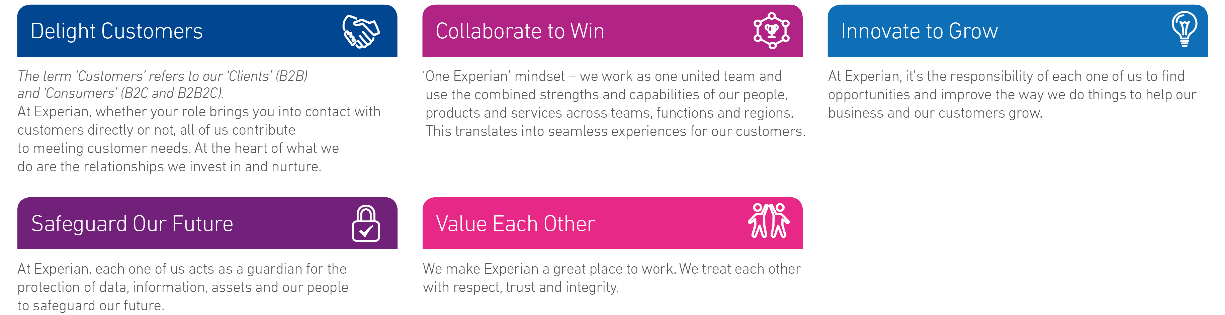

Value each other

# Role Profile

**Role Summary**

**ACTION NEEDED**

**Job purpose**

**ACTION NEEDED**

**Key Responsibilities**

* Spends the required number of hours of online time per day on the phones assisting clients.
* Should resolve cases primarily at desk via remote method.
* Provides thorough first and some limited second level technical support to resolve employee and client problems, and acts as the liaison throughout the problem resolution process between clients and subject matter experts responsible for escalated problems.
* Able to prioritize incoming request via phone vs request via emails from employees and clients for proper service management and KPI achievement.
* Receives employee and client requests for company products, services or other application assistance, identifies the source of the problem, determines the appropriate course of action to resolve the problem, using internal and external information sources and coaches the user through the resolution process.
* Able to own, maintain and resolve all cases which is assigned to you end to end.
* Assists employees and clients in completing or troubleshooting software installations, upgrades, communication and other application problems and/or walkthroughs.
* Following all departmental guidelines thoroughly documents and tracks all client reported issues using the current problem management application.
* Operates as the Expert Agent for assigned technology and/or applications and handling all responsibilities of that function.
* Achieves at minimum a level 3 or above in their Key Responsibility Area goals.
* Directly handles escalated issues assigned to them by the department Manager, Supervisor, or Lead.
* Assists management with support-related tasks.
* Makes recommendations for process improvements and technology changes within the department and helpdesk team.
* Assists with training and/or cross training of newly hired technicians, or existing technicians requiring or seeking additional training.

# Candidate Profile

**Skills & Experience**

* Excellent verbal communication skills.
* Applicants must be willing to work in Cyberjaya.
* Preferably Junior Executives specializing in IT/Computer - Network/System/Database Admin or equivalent.
* Full-Time position.

**Qualifications**

* Minimum of 2-3 years of customer of technical service/support required.
* Previous call center experience preferred with MNC company exposure.
* Strong remote troubleshooting skills with PC, Internet knowledge, Microsoft outlook, problem solving, analytical, and customer service skills required.
* Experience on CISCO VPN, Polycom, blackberry troubleshooting & basic Networking will be added advantage.
* Applicant should have ITIL framework knowledge.
* Possess a Degree in IT, Computer Science, Software Engineering or equivalent.